|  |  |  |  |  |  |
| --- | --- | --- | --- | --- | --- |
| Date | 30-Nov-22 | | | Tester Name | Jessie Liu |
| Environment | Select Environment | | | Login used |  |
| Operating System | Select OS | Version: | Update: | | |
| Software Used | Select Software | Version: | Update: | | |
| Select Software | Version: | Update: | | |
| Release version |  | | | | |
| Title | Enrolment | | | | |
| Test Type | Regression | | | | |
| Test Scenario | Enrol someone who is currently active with a different PEPP Employer | | | | |
|  |  | | | | |
| Expected Results |  | | | | |
| Pass/Fail | Fail | | | JIRA# | N/A |
|  | New enrolment PEPP employer’ department is created correctly, but look like the new department is overwritten the previous employer department | | |  |  |

Describe your steps with screenshots:

1. Find a member who is active

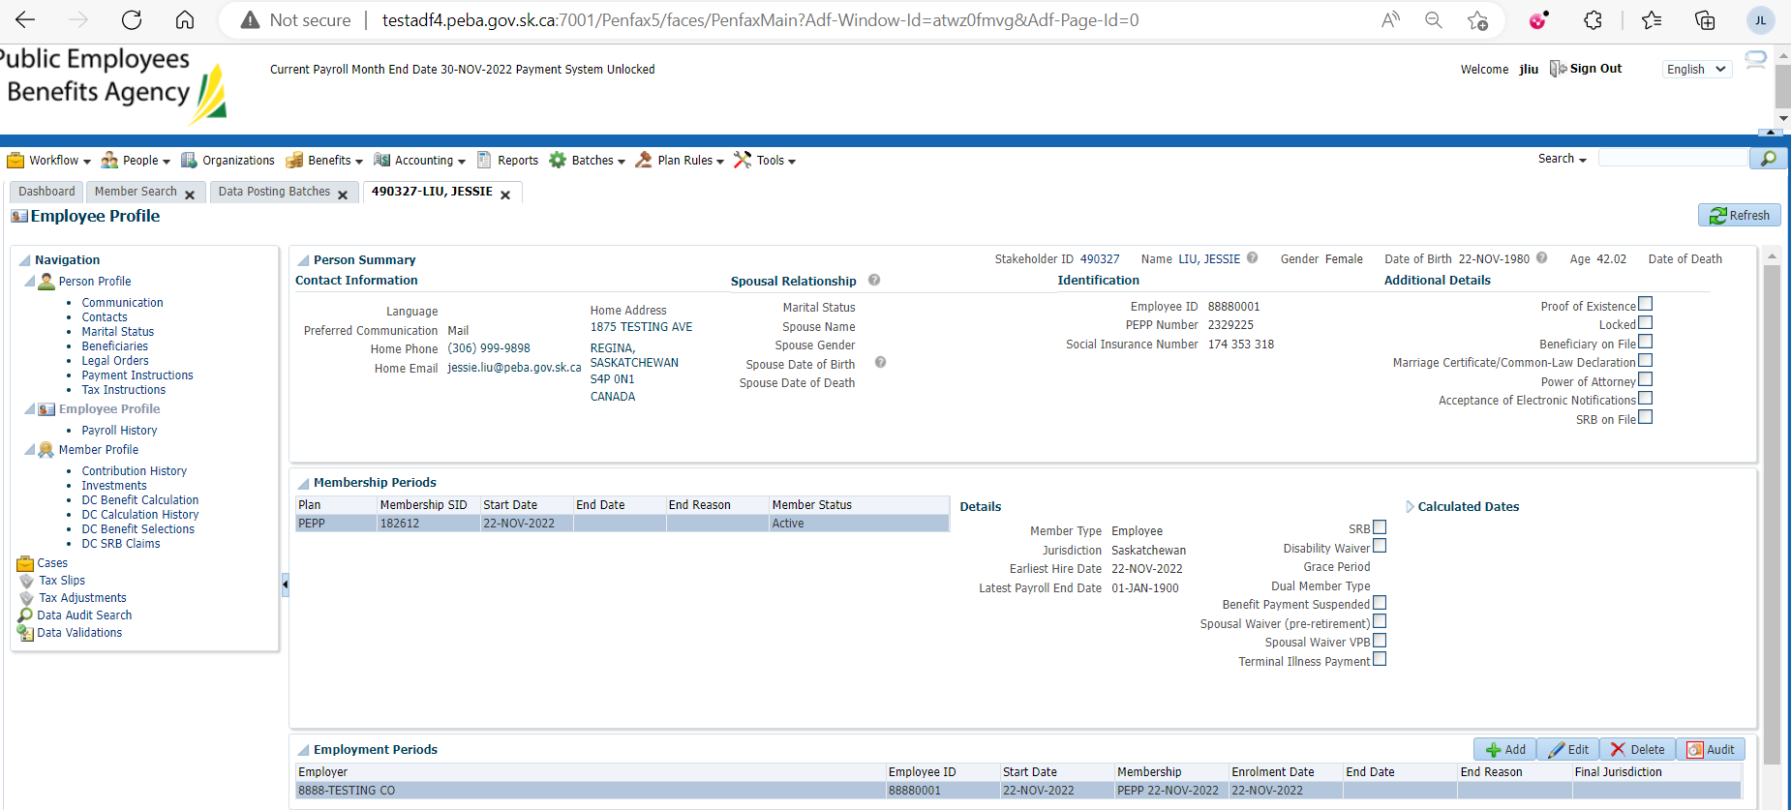

1. Enrol the member in different employer

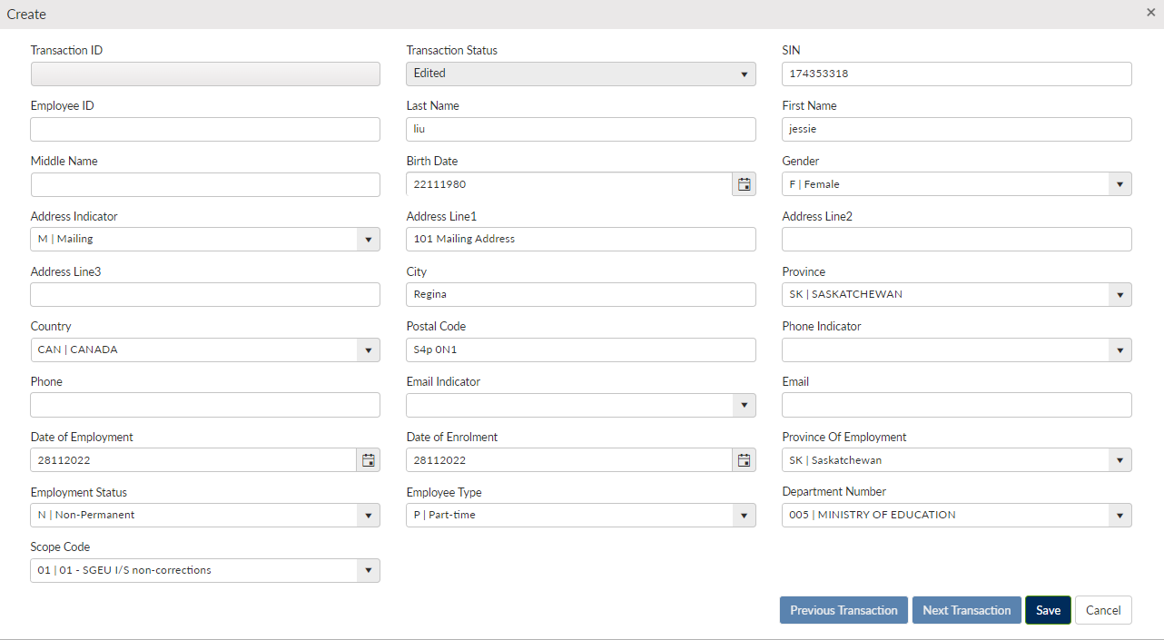

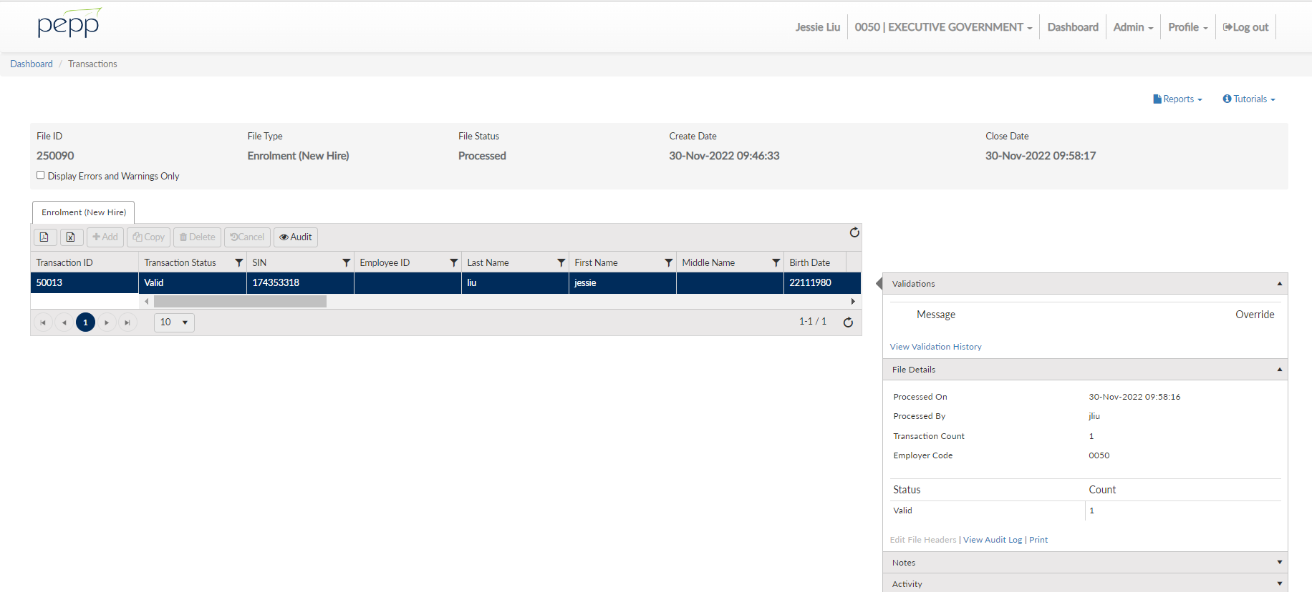

1. Data posting batch

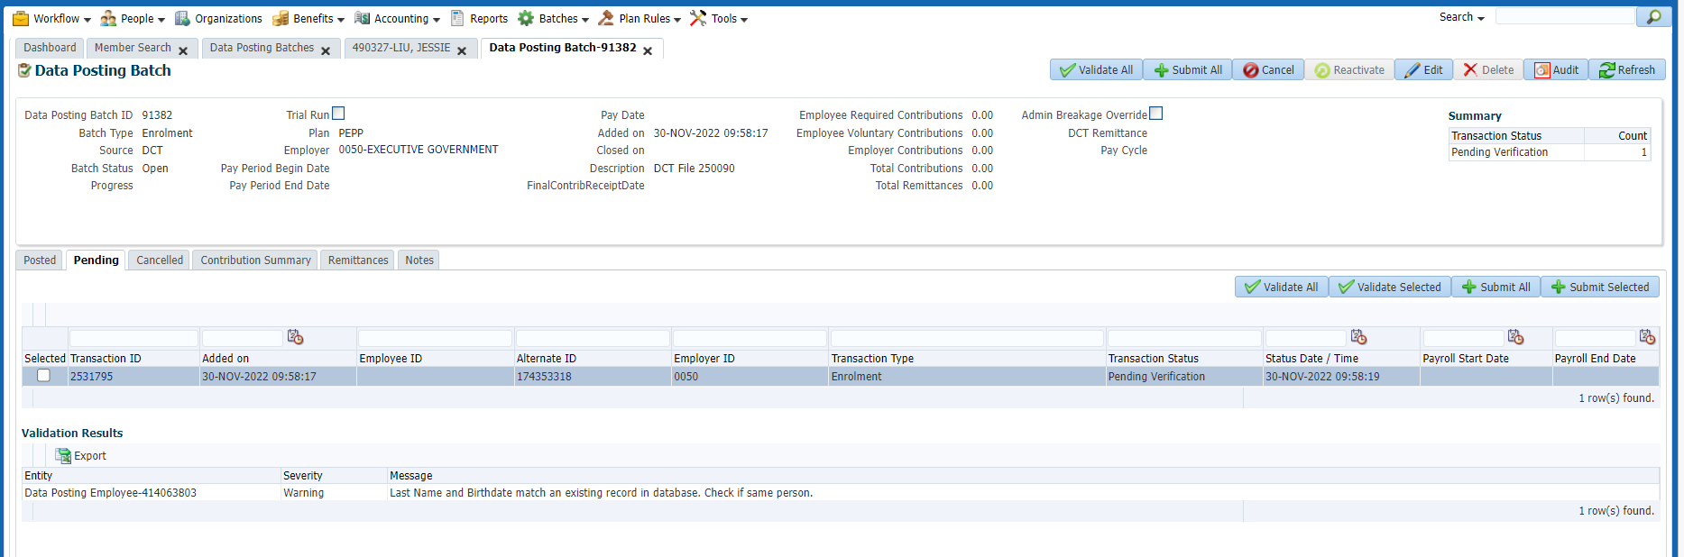

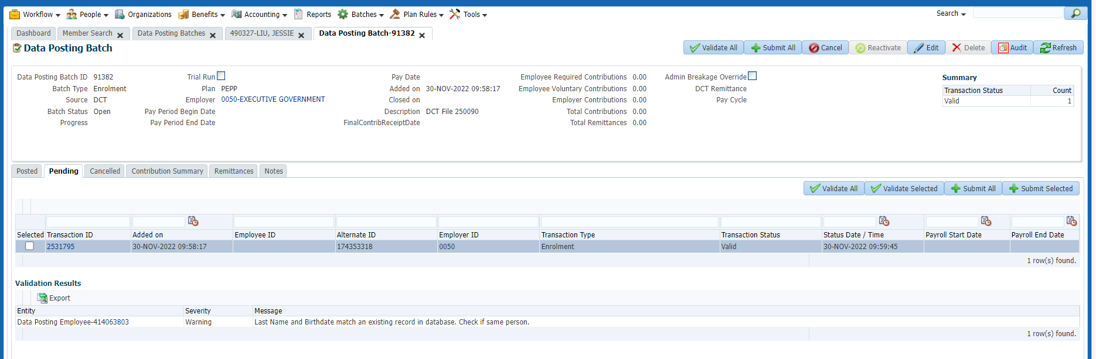

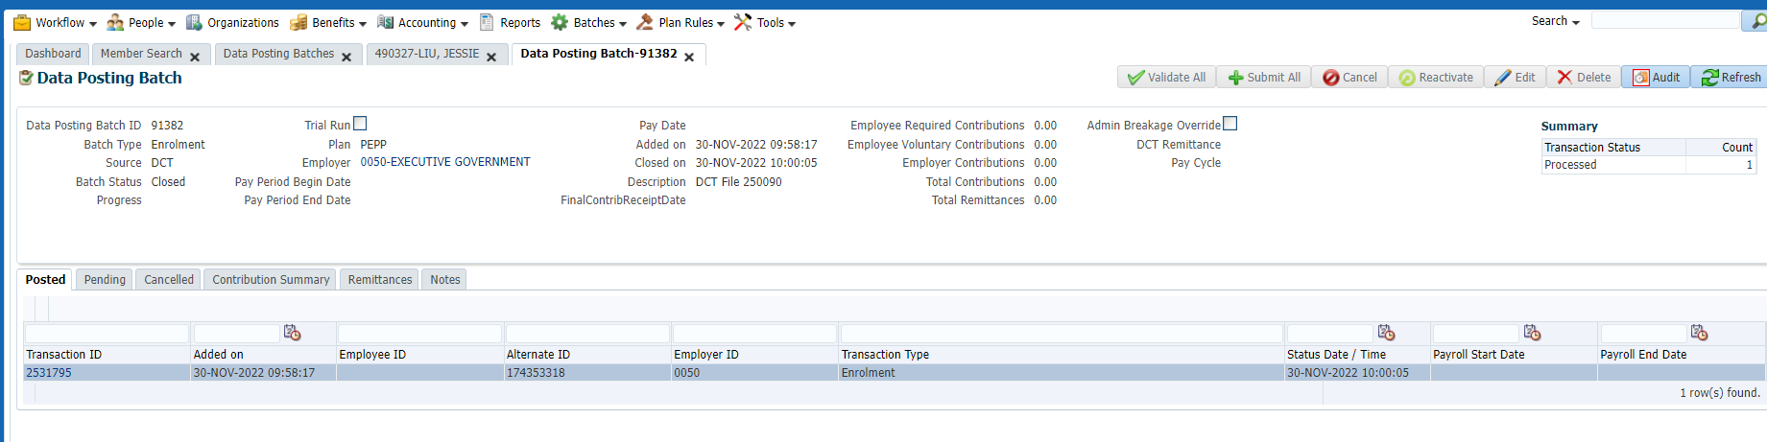

1. New employment is added

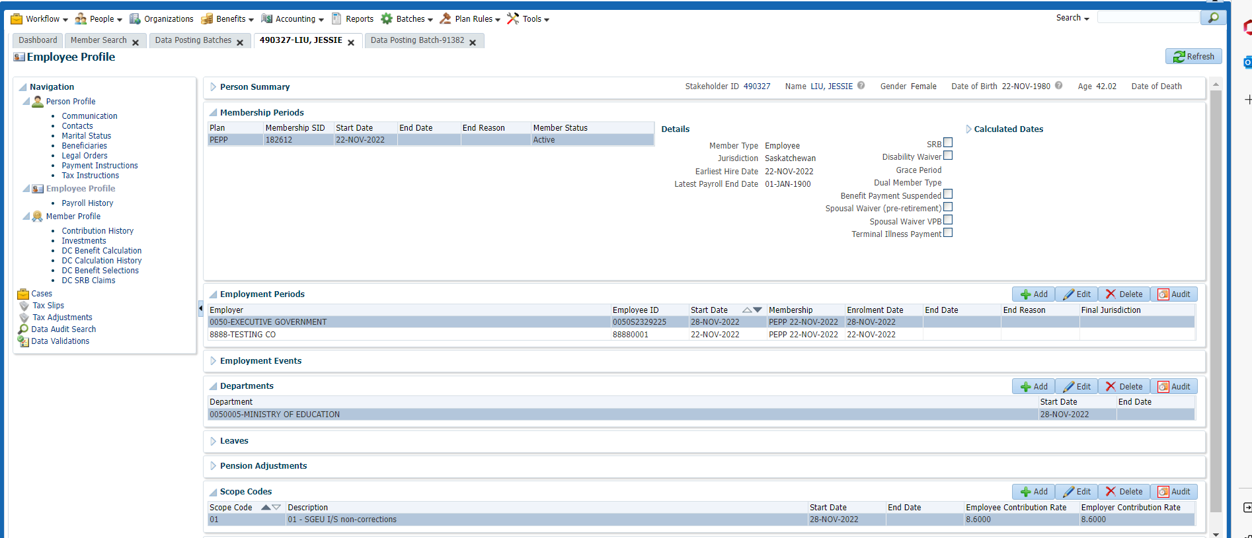

1. But previous employment department didn’t show correctly

